MTF Research Summary
John N. Rogers, III, Ryan Bearss, Jackie Guevara, and Evan Rogers
Michigan State University
January 2026

Research background: Since initiating the FIFA World Cup 2026 research program in 2022, our work primarily focused on the establishment of sod on plastic (SOP), including both stabilized and non-stabilized systems. In 2025, this body of work was largely completed, and emphasis transitioned to post-installation management.

Project updates:

Study #1: Strategies for optimizing hybrid carpet-mat hygiene of cool-season mixes grown on plastic during establishment

The objective of this research was to identify optimal strategies and frequencies for hygiene maintenance during the establishment of hybrid systems. The experiment was initiated in spring 2024 and will continue through summer 2026. For establishment, the HERO 127.127 hybrid carpet system was installed over a 3.5-mm blinding layer of USGA 90/10 (sand/peat), infilled to 25 mm, and seeded with an 84% Kentucky bluegrass (Poa pratensis L.) / 16% perennial ryegrass (Lolium perenne L.) mixture at 13 seeds in⁻². Treatments were mown 3x weekly to 25 mm. Beginning 10 weeks after establishment, plots received surface raking, vertical grooming (+3 mm), or both, applied weekly or monthly, with clippings either collected or returned. Treatments were applied for 12 months prior to harvest before being evaluated over a sand-based root zone and the Permavoid shallow profile. All treatments compared against a non-cultivated control.

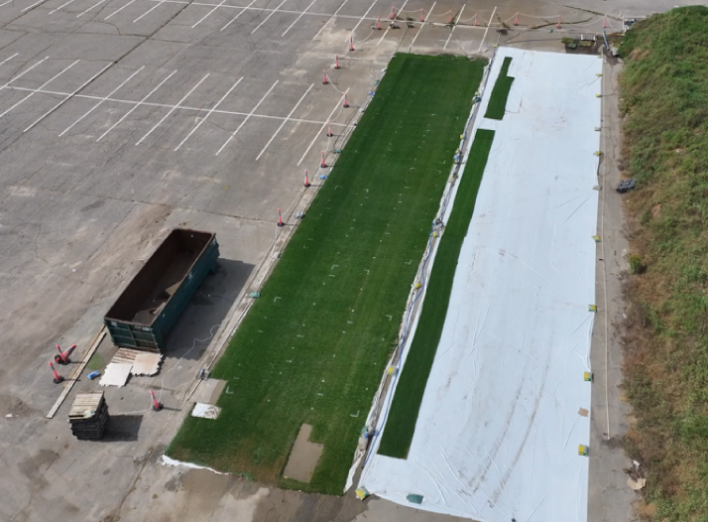
Figure 1. Experimental site of hybrid hygiene trials in the south lot of the HTRC (East Lansing, MI, 2025).
Key findings:
- Hygiene frequency and method significantly affected organic matter content, tiller density, rotational resistance, and divot resistance at 6 months after seeding; however, these effects were minimal following harvest and transplant at 12 months after establishment.
- Treatments that were vertically groomed or surface raked on a weekly basis achieved the most desirable results.
- An ideal hybrid hygiene program should begin >10 weeks < 12 weeks after seeding. Frequency of cultivation should be tailored to the growing climate and species being established.

